JECRC
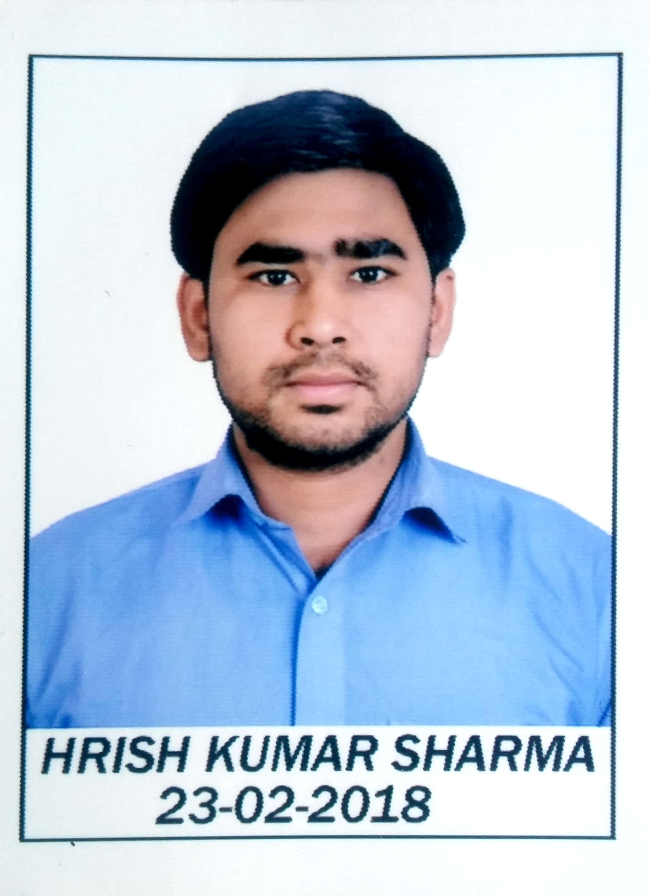
JAIPUR

INDIVIDUAL Lab Instructor DATA SHEET
Name of the Lab Instructor | : | Hrish Kumar Sharma
Present Designation | : | Wireless Communication Lab Instructor
Email Id : shrma.hk92@gmail.com
Contact Details : 9983859161

I. Particulars of Educational Qualification: (only completed)

Category | Name of the Degree | Specialization | Year of Passing | Name of the College | Name of the University
DIPLOMA | ENGINEERING DIPLOMA | ELECTRONICS | 2011 | DITE,MAKRANA | BTER JODHPUR
UG | B.TECH | ECE | 2014 | RTU,KOTA | RTU KOTA

II. Academic Experience : Two year

III. Industrial Experience : No

IV. Awards/Achievements : No

VI. Research/Specialization : No

VII. Course Taught : No

